RESTORATION OF PROCESSES

1. Check if "mtm.out" process exists by first executing the command below. If it any output, it means it exists and proceed to step 2. Telnet Background Server and then go to:

* /home/zxss10/bin #
* **ps -ef|grep out**    (Check for processes all.out and mtm.out)
* pkill -9 mtm.out (if it exists)

2. Navigate to the folder where the program is located using the following command:

* cd /home/zxss10/bin

3. Start the "mtm.out" process and send it to the background using the ampersand (&)

* ./mtm.out &

4. Check whether the processes have started running through the SS Management System

This is because of **mtm.out** process .   
  
telnet Background server and then go to /home/zxss10/bin # **ps -ef|grep out**    -----check process (all.out  mtm.out)   
  
Use the following command:   
  
ssdatabase:~ # **pkill -9 mtm.out  ----**if it exists   
  
ssdatabase:~ # cd /home/zxss10/bin   
ssdatabase:/home/zxss10/bin # **./mtm.out**   
  
  
If still can not be solved . i suggest restart the background server at night

**See every process on the Linux system**

Either pass -A or -e option to show all processes on your server/workstation powered by Linux:  
# ps -A  
# ps -e

**How to see every process except those running as root**

To negates the selection pass the -N or --deselect option to the ps command:  
# ps -U root -u root -N  
OR  
# ps -U root -u root --deselect

**Linux running processes with top command**

The top program provides a dynamic real-time view of a running system. Type the top at command prompt:  
# top

**How to display a tree of processes**

The [pstree command shows running processes as a tree](https://www.cyberciti.biz/faq/unix-linux-pstree-command-examples-shows-running-processestree/). The tree is rooted at either pid or init if pid is omitted. If a user name is specified, all process trees rooted at processes owned by that user are shown.  
$ pstree  
Sample outputs:  
[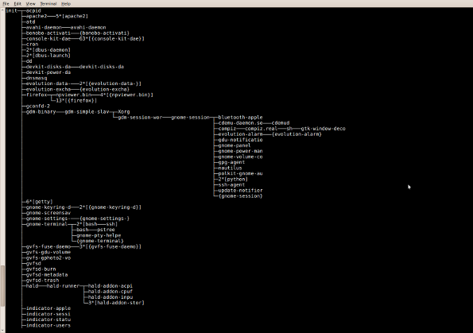](https://www.cyberciti.biz/faq/show-all-running-processes-in-linux/linux-unix-pstree-command/)Fig.02: pstree - Display a tree of processes

**Print a process tree using ps**

# ps -ejH  
# ps axjf  
Sample outputs:  
[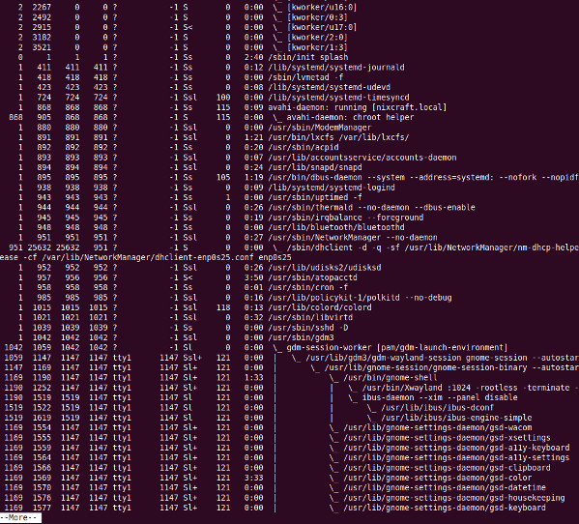](https://www.cyberciti.biz/media/new/faq/2006/10/linux-see-all-running-process-using-ps-command.jpg)Manage processes from the Linux terminal

**Get info about threads**

Type the following command:  
# ps -eLf  
# ps axms

**Task: Get security info**

Type the following command:  
# ps -eo euser,ruser,suser,fuser,f,comm,label  
# ps axZ  
# ps -eM

$ ps -fu oracle

UID        PID  PPID  C STIME TTY          TIME CMD  
oracle    2718  2716  0 06:50 ?        00:00:00 sshd: [oracle@pts/0](mailto:oracle@pts/0)  
oracle    2719  2718  0 06:50 pts/0    00:00:00 -bash  
oracle    2899  2897  0 07:14 ?        00:00:00 sshd: [oracle@pts/1](mailto:oracle@pts/1)  
oracle    2900  2899  0 07:14 pts/1    00:00:00 -bash  
oracle    3079  2900  0 07:40 pts/1    00:00:00 -bash  
oracle    3122  3079  0 07:40 pts/1    00:00:00 -bash  
oracle    3172  3122  0 07:40 pts/1    00:00:00 sqlplus         
oracle    3179     1  0 07:41 ?        00:00:00 ora_pmon_TEST  
oracle    3181     1  1 07:41 ?        00:00:00 ora_vktm_TEST  
oracle    3185     1  0 07:41 ?        00:00:00 ora_diag_TEST  
oracle    3187     1  0 07:41 ?        00:00:00 ora_dbrm_TEST  
oracle    3189     1  0 07:41 ?        00:00:00 ora_psp0_TEST  
oracle    3193     1  0 07:41 ?        00:00:00 ora_dia0_TEST  
oracle    3195     1  1 07:41 ?        00:00:00 ora_mman_TEST  
oracle    3197     1  0 07:41 ?        00:00:00 ora_dbw0_TEST  
oracle    3201     1  0 07:41 ?        00:00:00 ora_lgwr_TEST  
oracle    3203     1  0 07:41 ?        00:00:00 ora_ckpt_TEST  
oracle    3205     1  1 07:41 ?        00:00:00 ora_smon_TEST  
oracle    3207     1  0 07:41 ?        00:00:00 ora_reco_TEST  
oracle    3209     1  2 07:41 ?        00:00:00 ora_mmon_TEST  
oracle    3211     1  0 07:41 ?        00:00:00 ora_mmnl_TEST  
oracle    3213     1  0 07:41 ?        00:00:00 ora_d000_TEST  
oracle    3215     1  0 07:41 ?        00:00:00 ora_s000_TEST  
oracle    3222  3172 11 07:41 ?        00:00:01 oracleTEST  
(DESCRIPTION=(LOCAL=YES)(ADDRESS=(PROTOCOL=beq)))  
oracle    3224     1  1 07:41 ?        00:00:00 ora_fbda_TEST  
oracle    3226     1  0 07:41 ?        00:00:00 ora_smco_TEST  
oracle    3228     1  1 07:41 ?        00:00:00 ora_qmnc_TEST  
oracle    3230     1  1 07:41 ?        00:00:00 ora_w000_TEST  
oracle    3234  2719  0 07:41 pts/0    00:00:00 ps -fu oracle